QKN1 Task 1: Program Planning for Financial Data Analysis Using Python
Course: Analytics Programming — D598
Student: Dotun oduwale

Introduction
This project was completed for a small investment company that manages an equity fund consisting of approximately 150 U.S.-based companies operating across multiple states and industries. The purpose of this analysis is to assist fund managers in evaluating recent company performance and supporting informed portfolio rebalancing decisions.
The analysis uses Python programming to examine financial indicators such as debt, equity, revenue, and profitability. Prior to program development, this document outlines the program logic through a flowchart and pseudocode to demonstrate algorithmic thinking, as required by the task instructions.

A. Flowchart
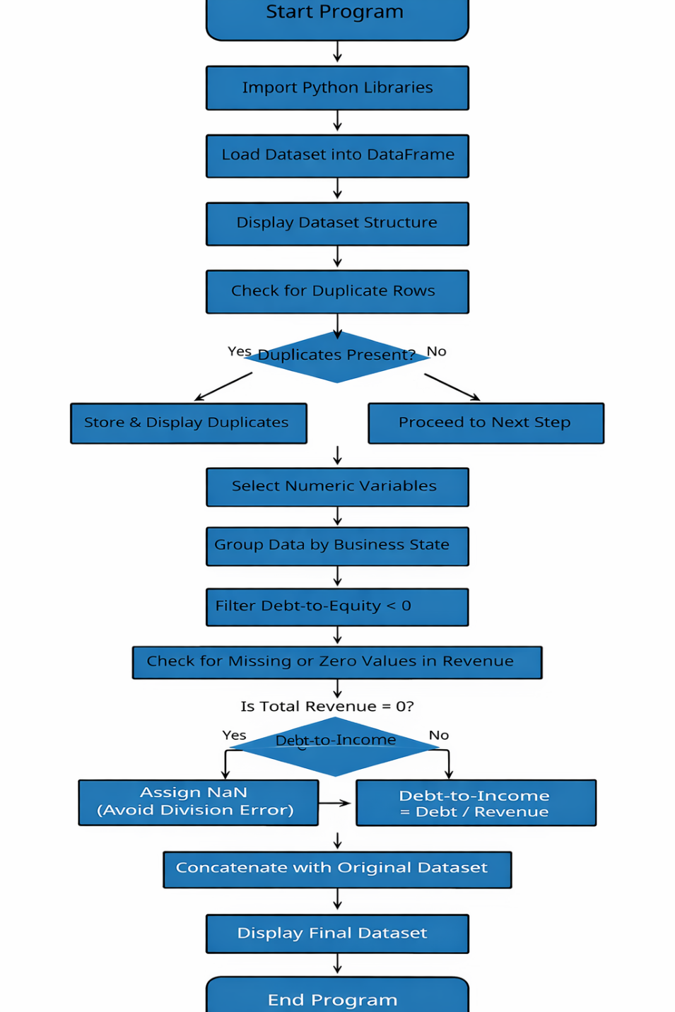
Screenshot should clearly show program flow from data import to final output.

B. Pseudocode
BEGIN

IMPORT required Python libraries

LOAD dataset into data frame df

DISPLAY dataset structure and summary

CHECK for duplicate rows in df

IF duplicate rows exist THEN
STORE duplicate rows
DISPLAY duplicate rows
ELSE
PROCEED to next step
END IF

SELECT all numeric financial variables

GROUP dataset by Business State

CALCULATE mean, median, minimum, and maximum
STORE results in new data frame state_stats

FILTER businesses where Debt-to-Equity ratio < 0
STORE results in negative_de_ratio

CREATE new data frame debt_to_income_df

FOR each record in df:
IF Total Revenue = 0 THEN
SET Debt_to_Income_Ratio = NaN
ELSE
SET Debt_to_Income_Ratio =
Total Long-term Debt / Total Revenue
END IF
END FOR

CONCATENATE debt_to_income_df with original df
STORE as final_df

DISPLAY final_df summary

END

C1. Explanation of Program Logic
The logic of the program follows a structured and sequential approach to financial data analysis. The program begins by importing the required libraries and loading the dataset into a data frame. Once the data is available, the program checks for duplicate records to ensure data integrity.
Next, the program groups the dataset by business state and calculates descriptive statistics—mean, median, minimum, and maximum—for all numeric financial variables. This provides a summarized view of financial performance at the state level.
The program then filters businesses with negative debt-to-equity ratios, which may indicate unusual financial structures or reporting issues. Afterward, a debt-to-income ratio is calculated for each business using long-term debt and revenue values. Finally, this newly calculated ratio is combined with the original dataset to produce a comprehensive financial analysis output.

C2. Alignment Between Flowchart and Pseudocode
The flowchart and pseudocode demonstrate one-to-one alignment in structure and logical sequence. Each process and decision point represented in the flowchart corresponds directly to a step in the pseudocode.
Flowchart Step | Corresponding Pseudocode Step
START | BEGIN
Import dataset into DataFrame | LOAD dataset into df
Display dataset structure | DISPLAY dataset summary
Check for duplicate rows | CHECK for duplicate rows
Decision: Are duplicates present? | IF duplicate rows exist THEN
Store & display duplicates | STORE and DISPLAY duplicates
Select numeric variables | SELECT numeric financial variables
Group by Business State | GROUP dataset by Business State
Calculate mean, median, min, max | CALCULATE descriptive statistics
Filter Debt-to-Equity < 0 | FILTER businesses where ratio < 0
Decision: Is Total Revenue = 0? | IF Total Revenue = 0 THEN
Set Debt-to-Income = NaN | SET Debt_to_Income_Ratio = NaN
Else calculate ratio | SET Debt / Revenue
Concatenate new DataFrame | CONCATENATE debt_to_income_df with df
END | END
This structured alignment ensures consistency between the visual representation of the program logic and the written algorithmic instructions. Each decision node in the flowchart is mirrored by conditional statements in the pseudocode, demonstrating clear algorithmic planning and logical accuracy.

D. Sources and References
No external sources were used in the development of this project. All program logic, pseudocode, and analysis were created independently based on the concepts learned during the Analytics Programming (D598) course.

E. Professional Communication Statement
This document has been prepared using clear, concise, and professional language appropriate for an academic and business audience. Grammar, spelling, and sentence structure have been carefully reviewed to ensure clarity and accuracy. The organization and formatting of the content support ease of reading and logical understanding of the program planning process.

Appendix (Optional)
Appendix A: Jupyter Notebook Output Screenshots & Code Implementation
The following screenshots demonstrate the successful execution of the Python program. Each screenshot corresponds directly to a specific analytical step described in the pseudocode and flowchart.

Screenshot 1: Data Import Confirmation (Preview)
Corresponding Python Code:
import pandas as pd
# Load dataset
df = pd.read_excel("D598 Data Set.xlsx")

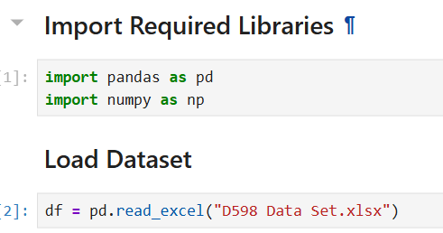
# Preview first 3 rows
df.head(3)
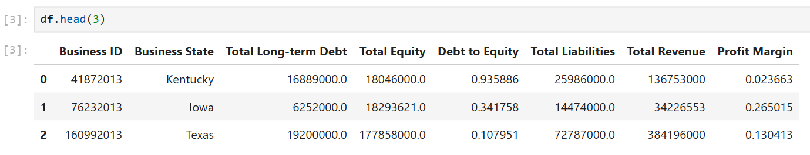
# Dataset structure overview
df.info()

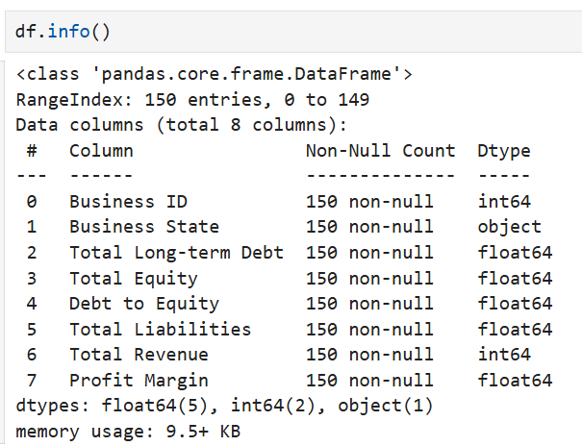

df.shape
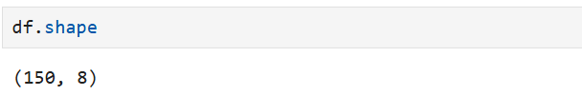

Screenshot 2: Duplicate Rows Identification (Preview)
Corresponding Python Code:
# Identify duplicate rows
duplicate_rows = df[df.duplicated()]
# Display duplicate records
duplicate_rows
# Count total duplicate rows
print("Total duplicate rows:", duplicate_rows.shape[0])
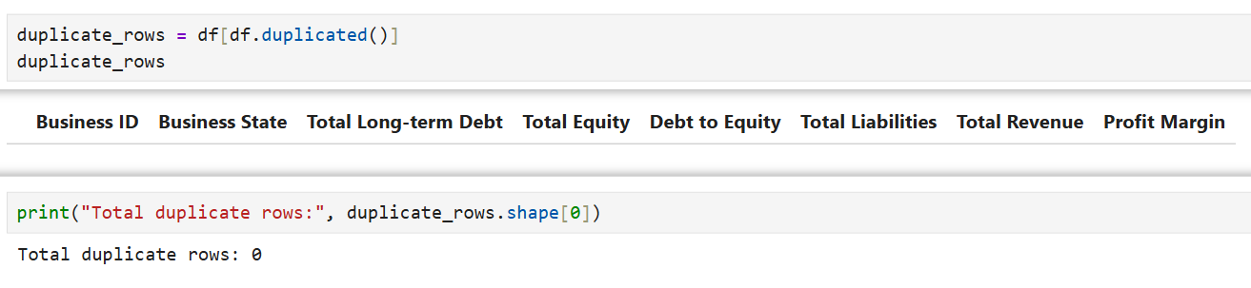
Screenshot 3: Grouped Descriptive Statistics by State (Preview)
Corresponding Python Code:
# Select numeric columns (excluding Business ID)
numeric_columns = df.select_dtypes(include=['int64', 'float64']).columns.drop('Business ID')
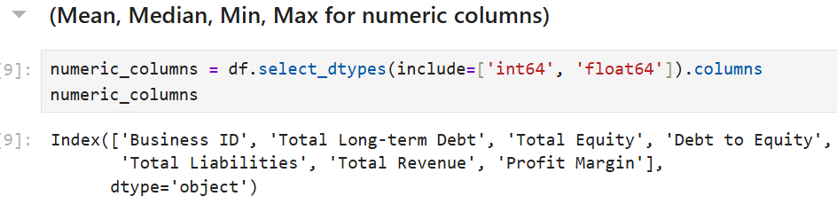
# Group by Business State and calculate descriptive statistics
state_stats = df.groupby("Business State")[numeric_columns].agg(
['mean', 'median', 'min', 'max']
)
# Display grouped statistics
state_stats.head()
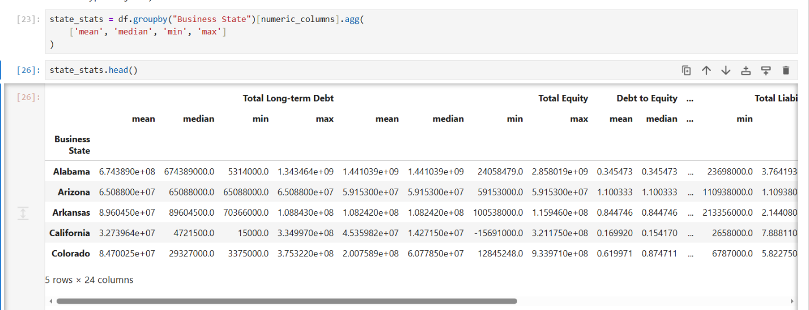

Screenshot 4: Negative Debt-to-Equity Ratio Filter (Preview)
Corresponding Python Code:
# Filter businesses with negative Debt-to-Equity ratio
df["Debt to Income"] = np.where(
df["Total Revenue"] == 0,
np.nan,
df["Total Long-term Debt"] / df["Total Revenue"]
)

# Display filtered records
df.head()

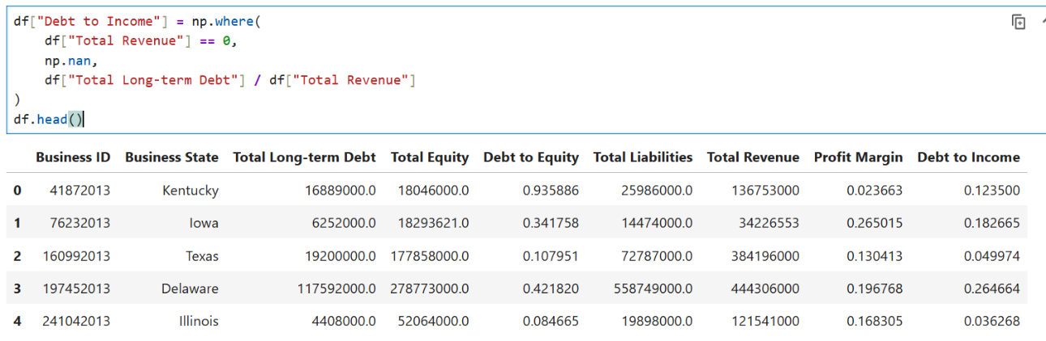

# Count businesses with negative ratio
print("Businesses with negative Debt-to-Equity ratio:", df["Debt to Income"].shape[0])

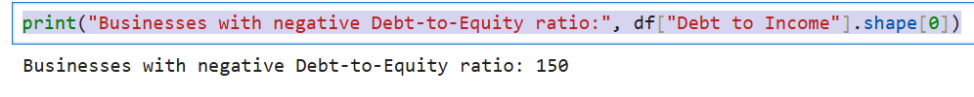

Screenshot 5: Final Concatenated Dataset (Preview)
Corresponding Python Code:
# Create Debt-to-Income Ratio safely
debt_to_income_df = pd.DataFrame()
debt_to_income_df["Debt_to_Income_Ratio"] = np.where(
df["Total Revenue"] == 0,
np.nan,
df["Total Long-term Debt"] / df["Total Revenue"]
)

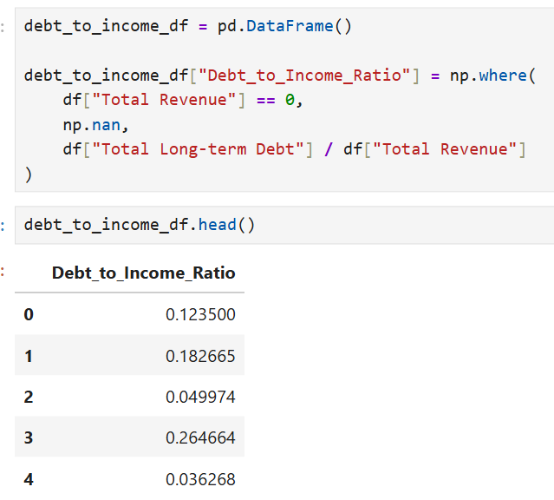
# Concatenate new ratio with original dataset
final_df = pd.concat([df, debt_to_income_df], axis=1)
# Display final dataset
final_df.head()
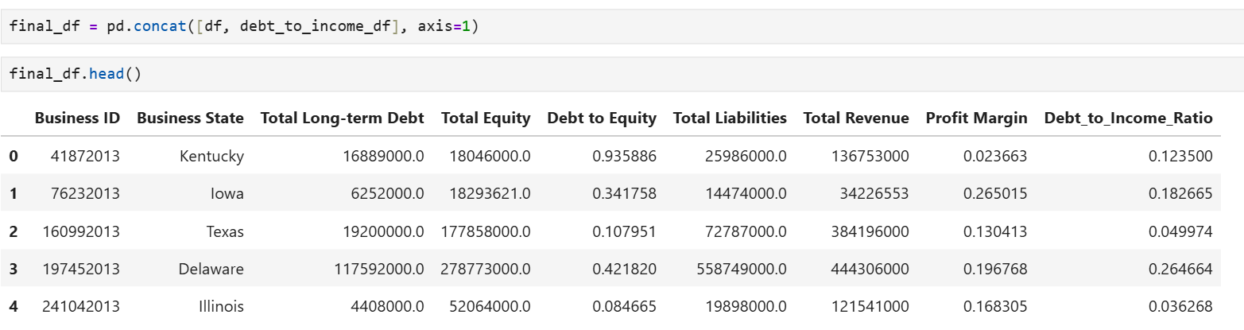
# Final dataset overview
final_df.info()

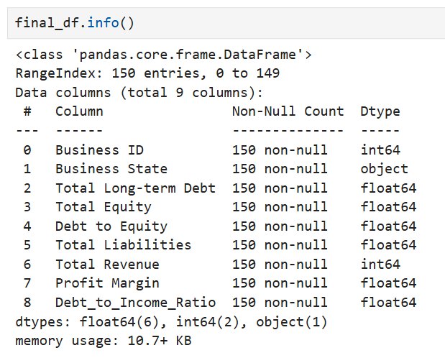

final_df.describe()

